- Budget Report & Analysis
- At the dashboard landing page, put the ff at the top of the report:
Control Name | Control Type | Options/ Behavior | Default Value
Primary Comparison | Single Select Dropdown | 1.Budget vs Actual  2.Last Year Actual vs Current Year Actual  3.Budget vs Forecast  4.Actual vs Forecast  5.5-Year Trend | Budget vs Actual
Financial Scope | Multi-Select Checkbox / Dropdown | 1.Operating Expense  2.Revenue  3.Non-Project Capex  4.Select All | Select All
Calendar Year | Single Select Dropdown | 1.2024  2.2025  3.2026  4.2027 | Current Active Calendar Year
Time Granularity | Segmented Control Button Group | Monthly / Quarterly / YTD / Annual | YTD
Saved View Presets | Quick Action Pill Buttons | 1.Executive Summary  2.Variance Alert View  3.5-Year Outlook | Executive Summary
- The dashboard is organized into three visual sections on a single screen.
- Section 1: KPI Summary Cards
Four dynamic stat boxes at the top that calculate numbers based on your filter selections:
- Baseline Card: Shows the main starting amount (e.g., Total Budget).
- Target Card: Shows the comparison amount (e.g., Total Actual Spent).
- Difference ($) Card: Shows the dollar gap ($\text{Target} - \text{Baseline}$).
- Variance (%) Badge: Shows percentage difference with color coding:
- Green: Favorable (Under budget on expenses, or above target on revenue).
- Red: Unfavorable (Over budget on expenses, or below target on revenue).
- Section 2: Visual Charts
- Comparison Chart (Time Trend): A main chart showing two bars (Baseline vs. Target) across months or quarters, plus a line showing % variance. Automatically adjusts to a 5-year trend line if selected.
- Scope Breakdown Chart: A donut chart showing the split between OpEx, Revenue, and Non-Project CapEx.
- Quick Feature: Clicking any pie slice automatically filters the data table below to show only that category.
- Section 3: Interactive Data Table & Heatmap
  - Folder-Style Rows: Categories start folded (Operating Expense, Revenue, Non-Project Capex). Click a row to expand and see specific line items (e.g., Software, Rent, Utilities).
  - Color Heatmap Cells: Automatically highlights high-variance rows in soft red ($>10\%$ over budget) or soft green ($>10\%$ under budget) so you spot issues immediately.
  - Built-in Tools:
  - Expand/Collapse All button.
  - Sort by highest dollar or percentage difference.
  - Search Bar to quickly find specific expenses.
  - Comment Button on each row to leave notes or review feedback.
- Budget Report & Analysis
- Revise the Primary Selection to the ff:
- Budget vs Actual
- Budget vs Forecast
- Forecast vs Actual
- Last Year Actual vs Current Year Actual
- Last Year Actual vs Current Year Forecast
- Last Year Actual vs Current Year Budget
- Monthly Comparison
- Quarterly Comparison
- Year dropdown selection – latest year should be the current year. Add year as necessary.
- Time Granularity for Monthly and Quarterly Comparison is not applicable (don't show the selection).
- Variance Alert View
- Put a field to put a variance in % and in Peso.
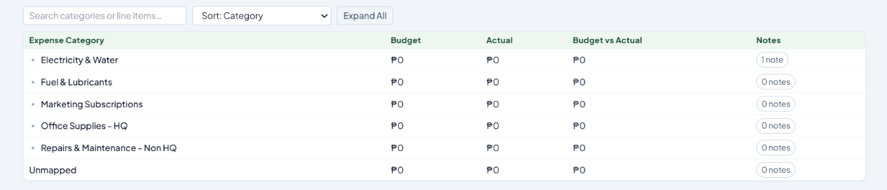
- Move this table at the top of the charts

- All tables and charts should be able to be viewed into a bigger pop-up window.
- 5-Year Outlook
- Remove '10-Year'
- Revise to '5-Year Trend' - this shows Budget vs Actual yearly trend for the past 4 years and current year. Show also the columns and rows figures, not only charts.
- Add to the filter section:
- SBU dropdown selection
- Annual Budget Setting
  - New Request – Revenue
- Remove the ‘My Revenue Requests’ section. Revenue requests should reflect also under ‘My Requests’.
  - Forecast – Revenue
- Make this identical with ‘New Request’.
  - Remove the ‘Approved Budget’ section:
